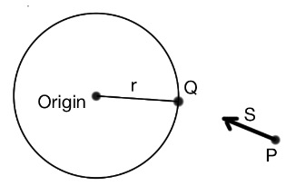

The equation for the sphere is:



Q is a vector from the origin to the point on the sphere surface. The r is a scalar whose magnitude is the radius of the sphere.

If a ray starts at point P and travels in direction S, then it will reach a point on the sphere surface where



Here, c is a constant of unknown size, equal to the distance traveled by the ray to reach the sphere point Q if S is a vector of unit length.

Combining the two equations above creates a quadratic equation for c.



Applying the quadratic equation gives the solution(s) for this equation.

The Matlab code resolves multiple solution issues (there should only be one intersect per ray). The code also reduces precision errors with additional numerical processing.Old solution:

Sphere on the origin



Parametric equations for a line in 3D space matrix for cross product



Parametric equations for a line in 3D space



and can be rewritten as:



Parametric equations for a line in 3D space, rewritten, the first two are the same equation:



Line intersect point to a sphere at the origin of radius r



Multiply everything by 



apply the quadratic formula:

